Providence Elementary
STEP Handbook
2017-2018

Ms. Kimberly Logsdon & Ms. Carron
Ms. Bogdanova & Ms. Lucy
Kimberly.Logsdon@vbschools.com
@kimgotcharacter (twitter)
http://gotcharacter.weebly.com/
Providence Elementary
Fourth & Fifth Grade, Room 11

Pioneer’s Mission Statement
As Providence teachers, we are committed to challenging students by creating critical thinkers and problem solvers. Each student's ideas and beliefs, unique and creative, are valued and respected. We will strive daily to create an environment in which students will become life-long learners with a desire to feed their minds so that they will be become productive and contributing members of society leaving their fingerprints on the world.
In STEP, our goal is to learn how to regulate our emotions while realizing it’s also ok to have them. We want to utilize strategies to positively and effectively communicate to ourselves and each other in respectful and productive ways that allows continual, healthy relationships.
Welcome to the VIP Learning Lab in Room 11!

What is the VIP Learning Lab?
The think tank is a safe place to explore, learn, and grow together. It is a place where we work together to ask and answer tough questions, think creatively, and problem solve. In other words, our brains should hurt by the end of the day!
Who is a member of the VIP Learning Lab?
- Students, of course!
- Parents!
- Teachers! Great minds don't always think alike so experts like our teacher assistants (Ms. Bogdanova and Ms. Lucy), speech specialist (Mrs. Shepard), reading specialist (Dr. Tower), math specialist (Mrs. Kraus), and the two inclusion teachers (Ms. Byers -4 & Ms. Herbst-5) will be working with us to differentiate and serve the needs of all learners!
- Support staff such as program psychologist (Dr. Yarnell), program social worker (Ms. Swan) and building administration (Mr. Taylor and Dr. Manigo).
Classroom Expectations

In our classroom we use the following classroom norms to help us learn and grow. These are simple rules, but they truly apply to every aspect of our day.

We are safe.
We are responsible.
We are kind and respectful.
We help ourselves and others to grow.
We have fun.

We use daily point sheet to track three goals that we are focusing for student success. We ask that parents sign the sheet every night and discuss highlights and areas for improvement!

Family Expectations
- Ensure your student is prepared and on time for school each day.
- Communicate any needs as soon as you can so we can help make provisions and be proactive in assisting your student as best as we can. Also, share highlights so we, too, can participate in these times, if desired, with your child.
- Support your student’s learning at home by asking questions about their day, reading with your student, and reviewing new material that they want to share.
Snacks
Students have the option of bringing a healthy snack to have during the day as well as a bottle of water to keep at their table. They may bring fresh fruit or veggies, granola bars, or crackers. Foods such as chips, candy, dessert snacks, or foods that need a utensil are not permitted. PLEASE send in a snack we can use with the class during snack time. (ie a box of pretzel bags)

Fourth & Fifth Grade Curriculum

Reading
We will focus on the different literature genres: fiction (such as realistic fiction, mysteries, historical fiction and folklore), nonfiction (biographies, informational), and poetry. Based on pre-assessments, students will be placed in differentiated small groups. These reading group placements are not permanent; they are flexible.
This year Virginia Beach Schools has purchased a differentiated online reading resource called Achieve 3000. The students will be logging onto this website 2-3 times a week in class to read non-fiction articles and completing comprehension activities as well. The articles will be given to each student at their own reading level. Students can log on at home as well if they so choose. This is a great tool to help your student grow as a non-fiction reader.
Students are expected to read an average of 20 minutes per school night. We are going to be working towards a 40 book challenge and their at home reading will assist them reach their goals!

Writing
Our writing program focuses mainly on narrative (telling a story) and expository (informational) pieces. Students will use writing workshop, which will focus on the writing process. We will also focus on the different traits of writing: ideas, organization, voice, word choice, sentence fluency, and conventions.
Writing will be used throughout our curriculum to create reports and informational pieces. We will also complete several mini-lessons throughout the year to include grammar usage, paragraph building, and research.

Word Study
Word Study takes the place of traditional spelling instruction. Each student will be given a pre-assessment. The pre-assessment will help determine the level that he/she will begin. While the words the student is learning each week may appear “easy”, the purpose is for students to learn and apply different spelling patterns as well as irregular spellings. Students will get plenty of chances to work with these words during the week.

Math
This year, we will focus on single and multi-step problems and real world applications of math. Areas of study will include multiplication, division, addition, subtraction, fractions, decimals, place value, geometry, measurement, and probability.
Remember, a key to learning math in fourth or fifth grade is to know all your multiplication facts! Everyone must practice at home to accomplish the goal of knowing all their facts before the first quarter is over! Practice with flashcards, worksheets, or a quality math website. Math homework is assigned as needed.

Science and Social Studies
The fourth and fifth grade curriculum in Virginia Beach combines the Virginia Beach Objectives with resource materials and is organized around the concept of exploration across disciplines. This integration will help students form a deeper understanding of their world by discovering patterns and natural links between factual knowledge and conceptual ideas that transfer through time, across cultures and across situations.

4th Grade Science and Social Studies Units

Unit 1: Earth, Moon, Sun Relationships
Unit 2: Geography and Weather
Unit 3: Earth Resources
Unit 4: Land and Ocean Ecosystems
Unit 5: Structures of Earth
Unit 6: Relationships in the Physical World
Unit 7: Physical Relationships in Virginia

5th grade Science and Social Studies
​Social Studies
​Unit 1 Physical Regions in Virginia
Unit 2 Interactions in Action
Unit 3 Colonial Virginia
​Unit 4 American Revolution in Virginia
​Unit 5 Reflections of Democracy
Unit 6 Civil War in Virginia
Unit 7 Rebuilding Virginia
Unit 8 Modern Virginia​
​Science
​Unit 1 Matter
Unit 2 Force, Motion, Energy
​Unit 3 Electricity
Unit 4 Sound
​Unit 5 Light
Unit 6 Cells and Classification
Unit 7 Plants

Google Classroom and Personalized Learning

In an effort to move towards a paperless classroom, we are doing many projects and assignments in our online classroom. We are really personalizing our learning on many levels. If you are curious about your student’s work on Google Classroom, students can log in and show you all of the terrific work they are doing. Google Classroom also gives students opportunities to work in a true collaborative spirit with others.

Furthermore, programs like Achieve 3000 and TenMarks caters to the needs of every individual. Whether it is extra practice or extensions, there is something for everybody. This is an exciting time to be in education.

Planners and Organization
Student Planners
Each student has a Student Planner that should travel between home and school every day. Students are responsible for writing their homework in their planner each day. Please check your student’s planner and make sure they have completed their work. If they are bringing home a blank planner, please let the teacher know.

These planners are going to be a crucial piece in communication between all VIPS: the teacher, the student, and the parent!
Daily reflective writing will be done in the student planners. Students will write about something that they learned today, something they want to keep working on, and/or a question or suggestion that they have. Please read over the reflective piece and sign it.
Students will have time at the end of the day to reflect on their learning and summarize it in their planners. Each day will include:

Something I learned today...

Something I want to keep working on…

A Question or suggestion I have...

Homework

Homework will consist of independent reading and reporting their planner reflections with their families on a daily basis. In a few weeks, students will begin creating online book reviews of books they have read. The end of the year goal is that students will have read at least 40 books by June.
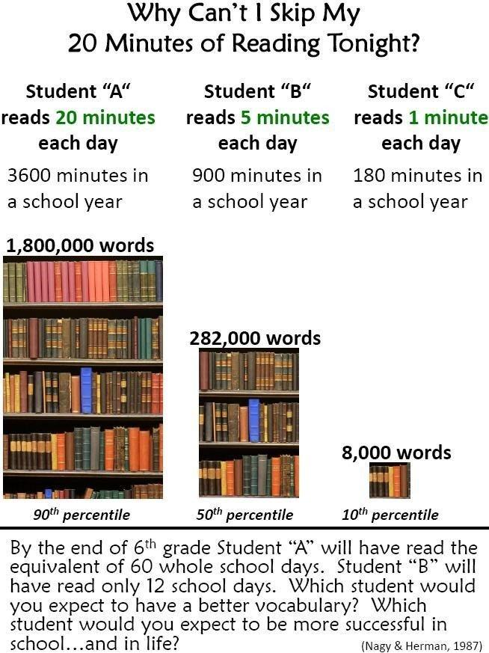

Grading Procedures

Standards Based Grading
Proficiency  Score | What does it mean?
AP | Advanced Proficient  You consistently demonstrate understanding, grasp, apply, and extend the key concepts, processes, and skills.
P | Proficient  You regularly grasp and apply key concepts, processes, and skills.
DP | Developing Proficiency  You are beginning to grasp and apply key concepts, processes, and skills.
N | Novice  You are not making expected progress towards proficiency.
Students will be assessed on the different objectives taught and will receive an overall proficiency score based on their level of achievement.
Formative and Summative Assessments
Formative (ongoing) and summative assessments will be returned to the student in the Tuesday Folder. Please review these assessments with your student. Assessments will be given back to take home and keep at the end of each nine weeks.

Late Work/Missing Work
Students are encouraged to turn in all work. Late or missing work will be noted and sent home, if needed, Thursday night prior to Fun Time Friday (FTF). All work must be completed prior to participating in FTF. Students will be given every opportunity to turn in work and, in some circumstances, given the chance to do work over.

BYOD – Bring Your Own Device
In our classroom, we try to integrate technology as much as possible. If your child has their own device, they are permitted to bring it to school as long as they follow the guidelines set forth by VBCPS and Providence. You can load books for independent reading as well as apps that will be used in school. Please always make sure the device is fully charged and your student is familiar with using it works. Also, with Providence now being a Digital Anchor School, all students will have access to a computer for their own use.

Daily Schedule (subject to change):

4th Grade
7:55-8:10 Morning
Announcements will be given via the television; expectations for the day will be discussed. Breakfast will also be offered to students during this time.
8:20-9:10 5th PE/ 4th Content
- 4th grade Art: 8:25-9:05, Monday
- 4th grade Music: 8:25-9:05, Wednesday
9:10-9:55 4th grade PE
- 5th grade Art: 9:10-9:55, Monday
- 5th grade Music: 9:10-9:55, Wednesday
9:55 - 10:15 Word Study
10:15 - 10:50 Making Meaning
10:50-11:00 Break / Snack
11:00 - 11:45 Small Groups / Individual & Group Therapy Times
11:50 - 12:20 Lunch
12:30 - 1:15- 4th/5th grade Math Mon - Ths
- Individual times (Mon & Tues)
- Library Friday
1:15 – 2:20 –Math
- Individual times (Tues & Ths)
- 1:45-2:30 5th grade PE, Monday
- 1:00 - 1:40 Fun Time Friday
- 1:45-2:30 4th grade PE, Friday
2:20 – 2:35 – Planner Reflection
2:40 Dismissal

Tuesday Folders
Every student is issued a Providence Folder. This is known as “The Tuesday Folder.” It is used to communicate any school and PTA notices. Please be sure to read the notices and return the folder by Thursday. Remember, in our effort to be more eco-friendly, more assignments will be online so the Tuesday folders will be light.

Birthdays
We have birthday celebrations for each student in which you are welcome to attend. You are welcome to bring in birthday treats for our class. Please make sure they are store bought and check in with me prior in case of allergies. We have an allergy to peanuts this year so please be aware when sending in snacks and birthday treats.

Field Trips
Students will have the opportunity to go on field trips with their classroom and their corresponding grade level. Students in STEP must be on the responsibility level before being allowed to attend any off campus field trips. In order to attend on campus field trips, they must at least be on self-control level.

Level System
All students in STEP follow a level system that indicates a “level” of support needed based on behavior. Each level varies in privileges earned and amount of staff supervision required for the student at the time. The levels are fluid as the student earns daily points on the daily goal sheets. In order to progress through the levels, students must earn a minimum of % at each level over a course of time. The levels are as follows:

Welcome Level: All new students entering the program
High Safety:
Safety:
Self-Control:
Responsibility:
Independence:
Role-Model: Exiting Students

A Note from the Teachers

I would like to thank you for taking the time to read our classroom handbook with your child. I appreciate everything you do as a parent and look forward to working with you this year.
My goal in the classroom is to develop a safe and positive learning environment that encourages respect and responsibility. I will work to the best of my ability to ensure that your child is learning and working at his or her developmental level.
If you have any questions or concerns please do not hesitate to contact me, I can be reached at school at 648- 3520. Leave a message and I will return your call. My e-mail address is kimberly.logsdon@vbschools.com. A note will work as well if that form of communication is easier for you. I am looking forward to a great school year! Please keep up with us with the following social media: twitter: @kimgotcharacter, gotcharacter.weebly.com, and our remind app for communication.

Thank you again for all of your support!

Sincerely,

The STEP Classroom Teachers
Kimberly Logsdon, Joyce Carron, Melanie Lucy, & Miriam Bogdanova
----------------------------------------------------------(Cut at dotted line) Kimberly Logsdon’s Handbook/Presentation
Please sign below and have your child bring it back to school as soon as possible!

Student signature ___________________________ Date _____________
Parent signature ___________________________ Date _____________

